# 

|  |  |
| --- | --- |
| Name | **Shivakumar Vollala** |
| Topic | **Bakery Management System** |
| Employee ID | **8133482** |
| Email ID | [**shivavollala@virtusa.com**](mailto:shivavollala@virtusa.com) |

SPECIFICATIONS 3

ABSTRACT 4

INTRODUCTION 4

SYSTEM REQUIREMENT SPECIFICATIONS 4

SYSTEM STUDY 4

PROPOSED SYSTEM 4

ADVANTAGES & DISADVANTAGES 5

FEATURES 5

SCOPE 5

# SPECIFICATIONS

|  |  |
| --- | --- |
| **Title of the Project** | **Bakery Management System** |
| **Hardware Requirements** | * Pentium4 (P4) or higher version. * 512 MB RAM or more. * 100 MB free space in Hard Disk. * Windows XP or Windows 7 version. |
| **Software Requirements** | * SQL Server 2008 * Microsoft Visual Studio 2010 |

# 

# ABSTRACT

Bakery Management System is totally computer based software application to maintain day to day transactions in a bakery. This software helps to store all bakery items with category and sub-category. It also maintains record of purchase and sales. It maintains details of Supplier.This application generates reports of purchase, sales and stock.

# INTRODUCTION

1. Organization
2. Existing System
3. Objectives of Proposed System

# SYSTEM REQUIREMENT SPECIFICATIONS

1. Requirement Gathering
2. Feasibility Study
3. System Analysis
4. System Design

# SYSTEM STUDY

1. Planning System
2. Analysis System
3. Design system
4. Implementation system

# PROPOSED SYSTEM:

The first advantage of the proposed system is that its front end provides easy and précised information to the user to interact with the system and hence it is faster to complete the work.

# ADVANTAGES & DISADVANTAGES FEATURES

# SCOPE

As one of the largest segments in the food processing sector in India, the bakery industry offers huge opportunities for growth, innovation, and job generation. Separated into three categories, bread, biscuits, and cakes and pastries, the bakery industry reached a market value of USD 7.22 billion in 2018.

**BAKERY**

**MANAGEMENT SYSTEM**

**INTRODUCTION**

1. **Organization**
2. **Existing System**
3. **Objectives of Proposed System**

#### INRODUCTION TO ORGANIZATION -

Bakery Management System is totally computer based software application to maintain day to day transactions in a bakery. This software helps to store all bakery items with category and sub-category. It also maintains record of purchase and sales. It maintains details of Supplier.

This application generates reports of purchase, sales and stock.

The system reflects standard structure so that any inventory management system can implements this system easily in their existing system. The system works to reduce the human efforts. Due to totally computerized occurrence of error is less & works smoothly. It is user friendly system.

#### INTRODUCTION TO EXISTING SYSTEM

**Manual System:**

Manual System is tedious and has lot of paperwork. It is not much accurate and ambiguity exists in the manual system. No. of registers have to be maintained. Calculations should be done manually. Stock has to be checked often.

#### 

#### 

#### 1.OBJECTIVE OF PROPOSED SYSTEM

* The main objective of the project is to design and develop a user friendly system.
* Easy to use and an efficient computerized system.
* To develop an accurate and flexible system, it will eliminate data redundancy.
* Computerization can be helpful as a means of saving time and mone
* To provide better Graphical User Interface (GUI).
* Less chances of information leakage.
* Provides Security to the data by using login and password method.

**2 .SYSTEM REQUIREMENT SPECIFICATIONS**

**Requirement Gathering**

1. Fact Finding Tools

**Feasibility Study**

1. Technical
2. Behavioral / Operational
3. Economical

**System Analysis**

1. Diagrams
2. Data Flow Diagram

**System Design**

1. Database Design
2. Data Dictionary

**User Interface Design**

* + Forms (Input Screens)
  + 0Reports (Output Screens)

#### SYSTEM STUDY:

**The first four phases of System Development Life Cycle:**

#### PLANNING PHASE:

The primary objectives of these phases are to identify the scope of the new system, ensures that the project is feasible, develop a schedule, allocate resources, and budget for the remainder of the project. The following are the five activities in the project-planning phase:

* Define the problem
* Confirm project feasibility
* Produce the project schedule
* Staff the project
* Launch the project

#### ANALYSIS PHASE:

The primary objectives of these phases are to understand the business needs and the processing requirements of the new system. Analysis is essentially a discovery process. The key words to drive the activities during analysis are discovery and understanding. There are six primary activities considered part of this phase:

* + Gather information
  + Define system requirements
  + Build prototypes for discovery of requirements
  + Prioritize requirements
  + Generate and evaluate alternatives
  + Review recommendations with management

#### DESIGN PHASE:

The objective of design phase is to design solution system. High-level design consists of developing an architectural structure for software programs, database, the user interface, and the operating environment. Low-level design emails developing the detailed algorithms and data structure that are required for program development. The design phase utilizes is its input the information obtained during the analysis phase. Seven major activities must be done during design. Design activities are closely interrelated and generally have substantial overlap .

Design and integrate network

* + Design the application architecture
  + Design user interfaces
  + Design system interfaces
  + Design the integrated database
  + Prototype for design details
  + Design and integrate the system controls

#### IMPLEMENTATION PHASE:

During the implementation phase, the final system is built, leads, and installed. The objectives of these phases are not only to have reliable, working information system but also to ensure that the users are all trained and that the business is benefiting. All the prior activities come together during this phase to culminate in an operational system. Six major activities make up the implementation phase:

* Construct software components
* Verify the test
* Develop prototypes for tuning
* Convert data
* Train and document

#### EXISTING SYSTEM:

The Bakery Management System is working manually. The current system is very time consuming and costly, because it involve lot of paper work. To manually handle such a system is very difficult task. But now-a-days because of computerization this job is becoming easier. Following are the reason why the current system should be computerized.

* + To increase efficiency with reduced cost.
  + To reduce the burden of paper work.
  + To save the time of recording details of every work undertaken by Bakery.
  + To check that the request for particular product is available.
  + To generate reports easily.

#### LIMITATION OF CURRENT SYSTEM:

* + - **Time consumption:** As the records are to be manually maintained it consumes a lot of time.
    - **Paper Work:** Lot of paper work is involved as the records are maintained in the files and registers.
    - **Storage Requirements:** As files and registers are used the storage space requirement is increased.
    - **Less Reliable:** Use of papers for storing valuable data information is not at all reliable.

**Accuracy:** As the system is in manual there are lot many chances of human errors. These cause errors in calculating mechanism or maintaining product and supplier data in registers

#### 

#### PROPOSED SYSTEM:

To reduce the inconvenience that found in the current system, it has been automated so as to provide user friendly GUI that will help data entry. This also includes report generation.

#### PROPOSED SYSTEM:

The first advantage of the proposed system is that its front end provides easy and précised information to the user to interact with the system and hence it is faster to complete the work.

The next advantage of the present system is that its faster capability to interact with the database. Even the database also provides its inbuilt features to maintain the records. It also provides the security to the records from the system itself and also from the database itself. Hence it prevents the database conjunction.

Another advantage of the proposed system is its faster capability to search the records from the database.

The proposed system provides both with the mouse or keyboard handling features to interact with the system.

### SYSTEM REQUIREMENT

**Hardware & Software to be used:**

* + - * Desktop Standard Requirements:
        + Pentium4 (P4) or higher version.
        + 512 MB RAM or more.
        + 100 MB free space in Hard Disk.
        + Windows XP or Windows 7 version.
      * Software:
        + SQL Server 2008
      * Development Tools:
* Microsoft Visual Studio 2010
* SQL Server 2008

# SYSTEM DIAGRAM

**DFD**

Order

0.0

Bill

Orde

Bill

System

Payme

Paymennnnnntnn

Recei

pt

Report

Supplier

Customer

Management

1

**r**



Gives Info

1.0

Master maintenance

Master

Supplier

3

Product detail

2

Customer

Supplier

Customer info

### SYSTEM DATABASE

**Category Master**

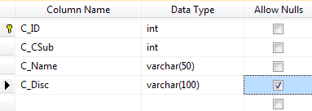

**ITEM MASTER**

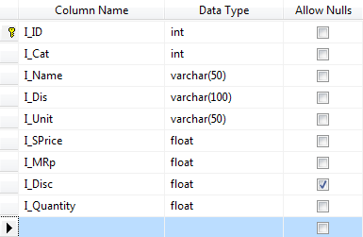

**PURCHASE MASTER**

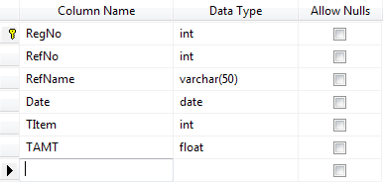

**PURCHASE DETAILS**

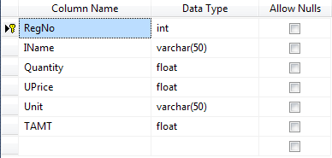

**RECEIVED DETAILS**

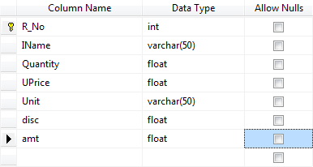

**RECEIPT MASTER**

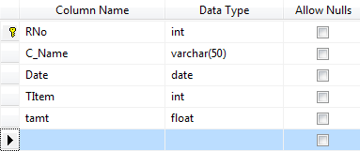

### SCREEN SHOTS

**LOGIN SCREEN**

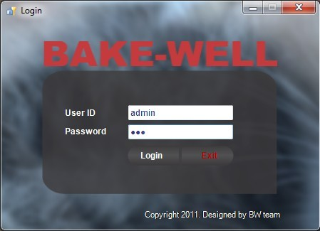

**PURCHASE FORM**

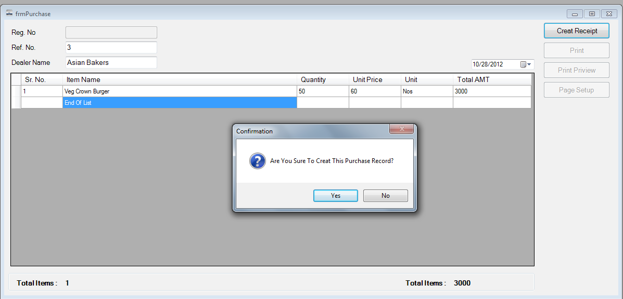

**SALES FORM**

**Add item Form**

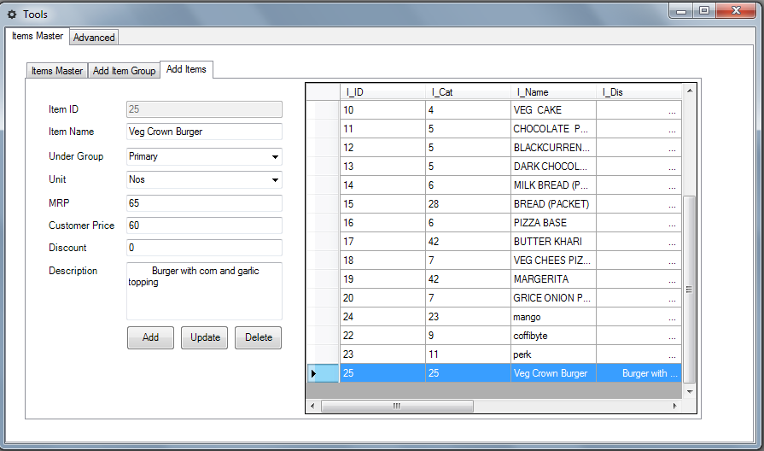**6+**

**SEARCH FORM**

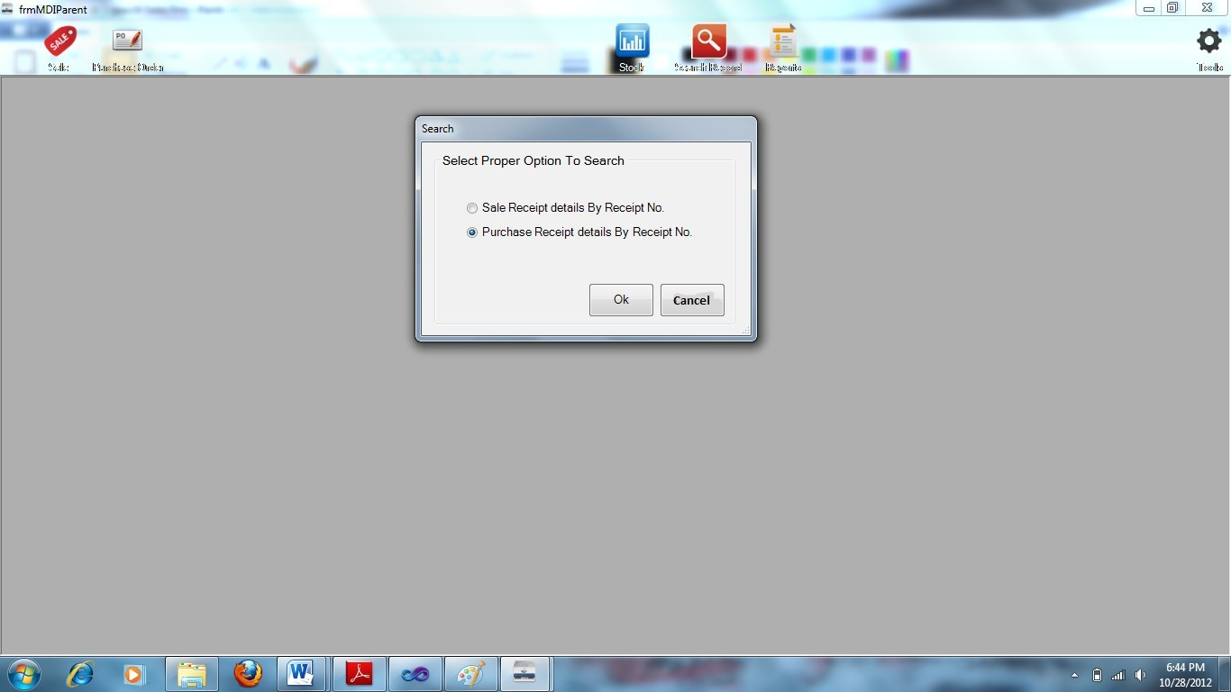

**SALES SEARCH FORM**

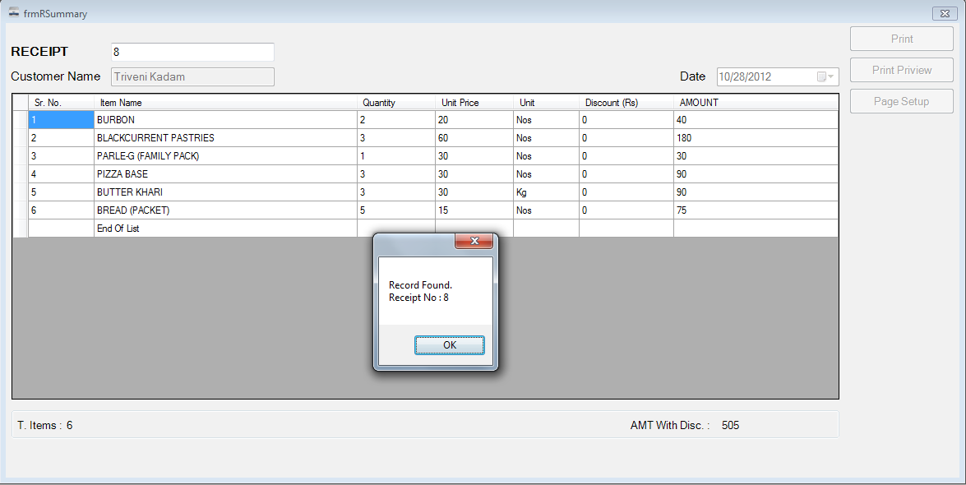

**STOCK FORM**

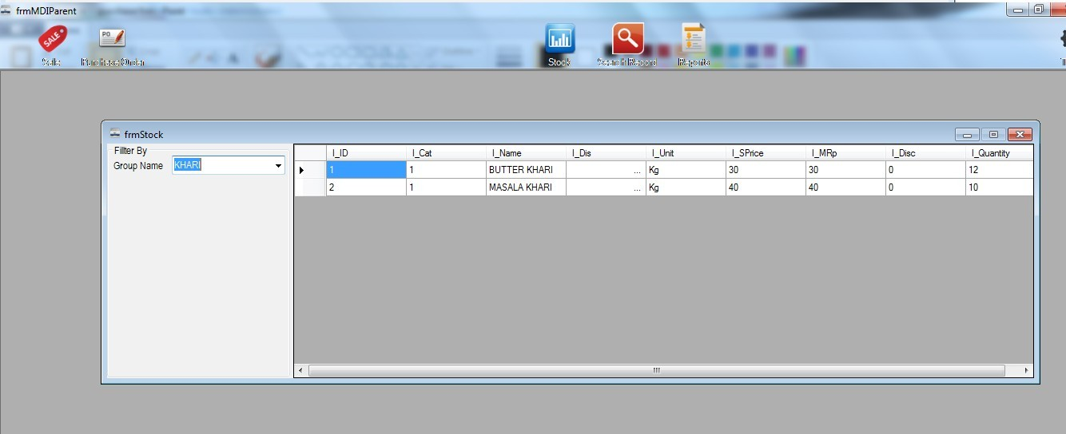

**PURCHASE REPORT**

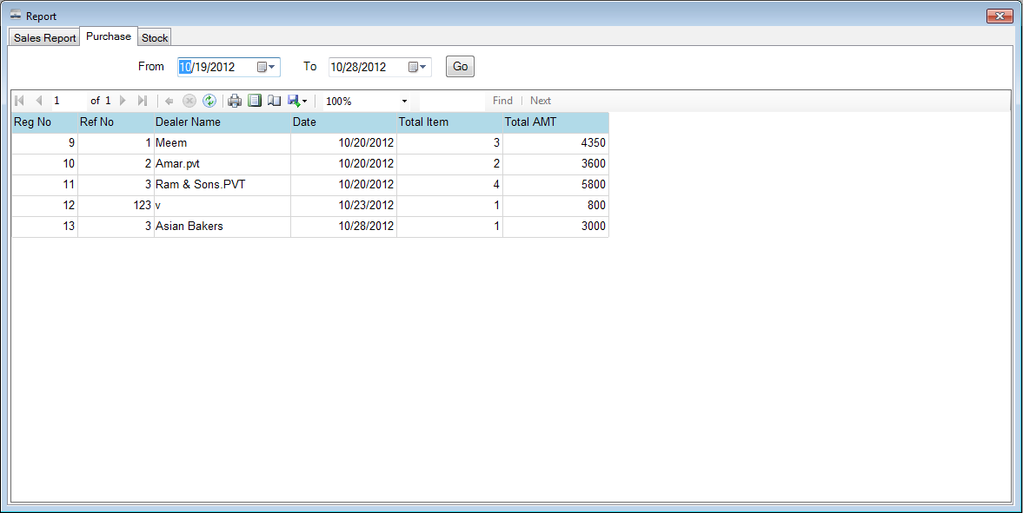

**SALES REPORT**

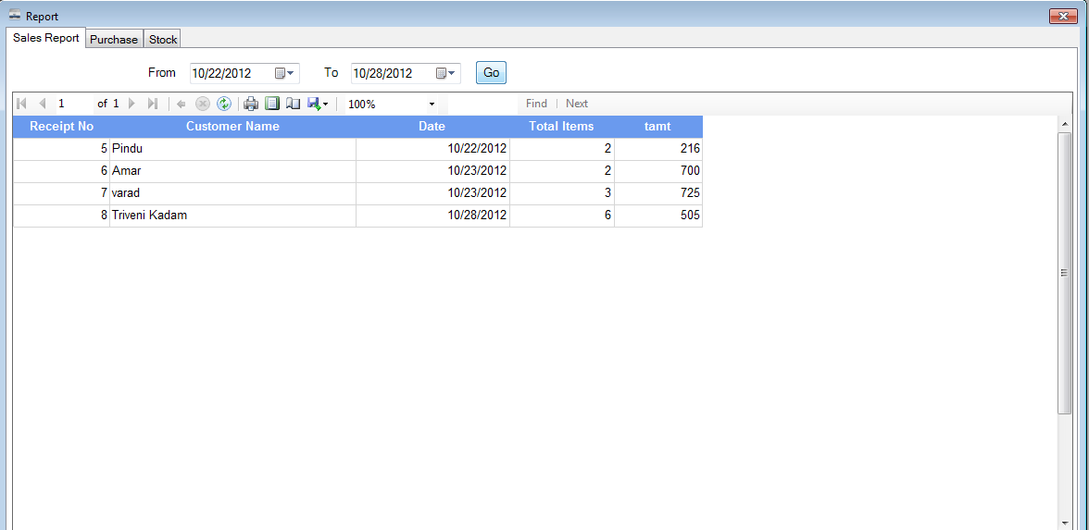

**STOCK REPORT**

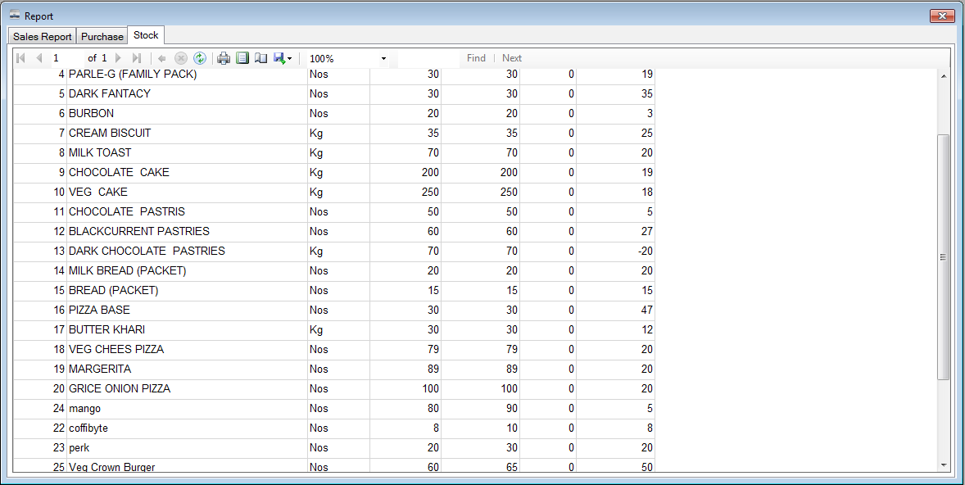

## 

## SOURCE CODE

**Purchase form**

using System;

using System.Collections.Generic; using System.ComponentModel; using System.Data;

using System.Drawing; using System.Linq; using System.Text;

using System.Windows.Forms; using System.Data.SqlClient;

namespace Dairy_Mng

{

public partial class frmPurchase : Form

{

#region Connection obj

SqlConnection cn = new SqlConnection("Data Source=.\\SQLEXPRESS;AttachDbFilename=D:\\Prj_Oct_2012\\Dairy_Mng\\Dairy_Mng\\d b.mdf;Integrated Security=True;User Instance=True");

SqlCommand cmd; SqlDataAdapter da; DataTable dt; #endregion

#region gbl obj

string fAdd = Properties.Settings.Default.Add; string mob = Properties.Settings.Default.Mob; TextBox txtName;

bool edit; #endregion

#region functions public int funMax()

{

int max = 0; try

{

cn.Open();

cmd = new SqlCommand("SELECT MAX(RegNo) FROM tblPMaster", cn); max = Convert.ToInt32(cmd.ExecuteScalar());

}

catch (Exception ex)

{

}

finally

{

cn.Close();

max = max + 1;

}

return max;

}

public void funInitializedComp()

{

txtRegNo.Text = ""; btnCRecipt.Text = "Creat Receipt"; txtDName.Clear(); txtRefNo.Clear(); txtDName.Enabled = true; flp.Enabled = false; dgvMList.Rows.Clear();

dgvMList.Rows.Add("1", "", "", "", "", "");

lblTAMT.Text = "0";

lblTItm.Text = "0"; btnPrint.Enabled = false; btnPPV.Enabled = false;

btnPSUp.Enabled = false; txtRefNo.Focus();

}

public void funArrangeSrNo()

{

float amt = 0;

for (int i = 0; i < dgvMList.Rows.Count - 1; i++)

{

dgvMList.Rows[i].Cells[0].Value = i + 1;

amt = amt + float.Parse(dgvMList.Rows[i].Cells[5].Value.ToString()); lblTItm.Text = (i + 1).ToString();

}

lblTAMT.Text = amt.ToString();

}

#endregion

public frmPurchase()

{

txtName = new TextBox(); InitializeComponent();

}

private void frmPurchase_Load(object sender, EventArgs e)

{

#region Load Items Data try

{

cn.Open();

cmd = new SqlCommand("SELECT * FROM tblItmMaster", cn); da = new SqlDataAdapter(cmd);

dt = new DataTable(); da.Fill(dt);

for (int i = 0; i < dt.Rows.Count; i++)

{

txtName.AutoCompleteCustomSource.Add(dt.Rows[i].ItemArray[2].ToString());

}

txtName.AutoCompleteCustomSource.Add("End Of List");

}

catch (Exception ex)

{

MessageBox.Show(ex.Message);

}

finally

{

cn.Close();

}

#endregion funInitializedComp();

}

private void dgvMList_EditingControlShowing(object sender, DataGridViewEditingControlShowingEventArgs e)

{

TextBox txtACS = e.Control as TextBox; txtACS.AutoCompleteMode = AutoCompleteMode.Suggest;

txtACS.AutoCompleteSource = AutoCompleteSource.CustomSource; int swt = dgvMList.CurrentCell.ColumnIndex;

switch (swt)

{

case 1:

txtACS.AutoCompleteCustomSource = txtName.AutoCompleteCustomSource;

break;

case 2:

txtACS.AutoCompleteCustomSource = null; break;

default:

break;

}

}

private void frmPurchase_FormClosing(object sender, FormClosingEventArgs e)

{

e.Cancel = false;

}

private void btnExit_Click(object sender, EventArgs e)

{

this.Close();

}

private void txtDName_Leave(object sender, EventArgs e)

{

if (string.IsNullOrWhiteSpace(txtDName.Text))

{

txtDName.Focus();

}

}

private void txtRefNo_Leave(object sender, EventArgs e)

{

int rout;

if (string.IsNullOrWhiteSpace(txtRefNo.Text) || int.TryParse(txtRefNo.Text,out rout)==false)

{

txtRefNo.Focus();

}

}

private void dgvMList_KeyDown(object sender, KeyEventArgs e)

{

if (e.KeyCode == Keys.Enter)

{

if (dgvMList.CurrentRow.Cells[5].Selected == true && dgvMList.CurrentRow.Index == dgvMList.Rows.Count-1 &&

dgvMList.Rows[dgvMList.Rows.Count - 1].Cells[1].Value.ToString() != "End Of List")}

{

dgvMList.Rows.Add("", "", "", "", "", "");

dgvMList.CurrentRow.Cells[1].Selected = true;

}

}

private void dgvMList_CellBeginEdit(object sender, DataGridViewCellCancelEventArgs e)

{

edit = true;

}

private void dgvMList_CellEndEdit(object sender, DataGridViewCellEventArgs e)

{

edit = false;

}

private void dgvMList_RowsAdded(object sender, DataGridViewRowsAddedEventArgs e)

{

funArrangeSrNo();

}

private void dgvMList_RowsRemoved(object sender, DataGridViewRowsRemovedEventArgs e)

{

funArrangeSrNo();

}

#region menu validation

private void dgvMList_CellValidating(object sender, DataGridViewCellValidatingEventArgs e)

{

switch(e.ColumnIndex)

{

case 1:

#region M Name

if (string.IsNullOrWhiteSpace(e.FormattedValue.ToString()))

{

e.Cancel = true;

}

else if (txtName.AutoCompleteCustomSource.Contains(e.FormattedValue.ToString()) == false)

{

MessageBox.Show("Spelling Error"); e.Cancel = true;

}

else

{

}

#endregion break;

case 2:

#region quantity

if (dgvMList.Rows[e.RowIndex].Cells[1].Value.ToString() != "End Of List")

{

float f;

if (string.IsNullOrWhiteSpace(e.FormattedValue.ToString()))

{

e.Cancel = true;

}

else if (float.TryParse(e.FormattedValue.ToString(), out f) == false)

{

e.Cancel = true;

}

else

{

}

}

#endregion break;

case 3:

#region U Price

if (dgvMList.Rows[e.RowIndex].Cells[1].Value.ToString() != "End Of List")

{

float f;

if (string.IsNullOrWhiteSpace(e.FormattedValue.ToString()))

{

e.Cancel = true;

}

else if (float.TryParse(e.FormattedValue.ToString(), out f) == false)

{

e.Cancel = true;

}

else

{

}

}

#endregion break;

default:

break;

}

}

private void dgvMList_CellValidated(object sender, DataGridViewCellEventArgs e)

{

int r = e.RowIndex;

int c = e.ColumnIndex; switch (c)

{

case 1:

#region Menu Name if (edit == true)

{

List")

if (dgvMList.Rows[e.RowIndex].Cells[1].Value.ToString() != "End Of

{

dgvMList.Rows[e.RowIndex].Cells[2].Value = "0"; int iIx =

txtName.AutoCompleteCustomSource.IndexOf(dgvMList.Rows[e.RowIndex].Cells[1].Val ue.ToString());

dgvMList.Rows[e.RowIndex].Cells[3].Value = "0"; dgvMList.Rows[e.RowIndex].Cells[4].Value =

dt.Rows[iIx].ItemArray[4].ToString();

dgvMList.Rows[e.RowIndex].Cells[5].Value = Convert.ToDecimal(dgvMList.Rows[e.RowIndex].Cells[2].Value) *

Convert.ToDecimal(dgvMList.Rows[e.RowIndex].Cells[3].Value);

}

else

{

for (int i = 2; i < 5; i++)

{

dgvMList.CurrentRow.Cells[i].Value = "";

}

float amt = 0;

for (int i = 0; i < dgvMList.Rows.Count - 1; i++)

{

lblTItm.Text = (i + 1).ToString(); amt = amt +

float.Parse(dgvMList.Rows[i].Cells[5].Value.ToString());

}

flp.Enabled = true; btnCRecipt.Focus();

}

}

#endregion break;

case 2:

#region Quantity

if (dgvMList.Rows[e.RowIndex].Cells[1].Value.ToString() != "End Of List")

{

dgvMList.Rows[e.RowIndex].Cells[5].Value = Convert.ToDecimal(dgvMList.Rows[e.RowIndex].Cells[2].Value) *

Convert.ToDecimal(dgvMList.Rows[e.RowIndex].Cells[3].Value);

}

else

{

dgvMList.Rows[e.RowIndex].Cells[2].Value = "";

}

#endregion break;

case 3:

#region Quantity

if (dgvMList.Rows[e.RowIndex].Cells[1].Value.ToString() != "End Of List")

{

dgvMList.Rows[e.RowIndex].Cells[5].Value = Convert.ToDecimal(dgvMList.Rows[e.RowIndex].Cells[2].Value) *

Convert.ToDecimal(dgvMList.Rows[e.RowIndex].Cells[3].Value);

}

else

{

dgvMList.Rows[e.RowIndex].Cells[3].Value = "";

}

#endregion break;

default:

break;

}

}

#endregion

private void btnCRecipt_Click(object sender, EventArgs e)

{

if (btnCRecipt.Text == "Creat Receipt")

{

if (MessageBox.Show("Are You Sure To Creat This Purchase Record?", "Confirmation",

MessageBoxButtons.YesNo, MessageBoxIcon.Question) == DialogResult.Yes)

{

int max = funMax();

#region save & update record try

{

cn.Open();

cmd = new SqlCommand("INSERT INTO tblPMaster (RegNo, RefNo, RefName, Date, TItem, TAMT) VALUES (@regno,@refno,@name,@dt,@ti,@amt)", cn);

cmd.Parameters.Add("@regno", SqlDbType.Int).Value = max; cmd.Parameters.Add("@refno", SqlDbType.Int).Value =

int.Parse(txtRefNo.Text);

cmd.Parameters.Add("@name", SqlDbType.VarChar).Value = txtDName.Text;

cmd.Parameters.Add("@dt", SqlDbType.Date).Value = dtp.Value; cmd.Parameters.Add("@ti", SqlDbType.Int).Value =

int.Parse(lblTItm.Text);

cmd.Parameters.Add("@amt", SqlDbType.Float).Value = int.Parse(lblTAMT.Text);

cmd.ExecuteReader();

}

catch (Exception ex)

{

MessageBox.Show(ex.Message);

}

finally

{

cn.Close();

}

try

{

for (int i = 0; i < dgvMList.Rows.Count - 1; i++)

{

cn.Open();

cmd = new SqlCommand("INSERT INTO tblPDetails (RegNo, IName, Quantity, UPrice, Unit, TAMT) VALUES (@no,@nm,@qt,@up,@u,@amt)", cn);

cmd.Parameters.Add("@no", SqlDbType.Int).Value = max; cmd.Parameters.Add("@nm", SqlDbType.VarChar).Value =

dgvMList.Rows[i].Cells[1].Value.ToString();

cmd.Parameters.Add("@qt", SqlDbType.Int).Value = int.Parse(dgvMList.Rows[i].Cells[2].Value.ToString());

cmd.Parameters.Add("@up", SqlDbType.Float).Value = float.Parse(dgvMList.Rows[i].Cells[3].Value.ToString());

cmd.Parameters.Add("@u", SqlDbType.VarChar).Value = dgvMList.Rows[i].Cells[4].Value.ToString();

cmd.Parameters.Add("@amt", SqlDbType.Float).Value = float.Parse(dgvMList.Rows[i].Cells[5].Value.ToString());

cmd.ExecuteReader(); cn.Close();

}

}

catch (Exception ex)

{

MessageBox.Show(ex.Message);

}

Finally

{

}

try

{

for (int i = 0; i < dgvMList.Rows.Count - 1; i++)

{

cn.Open();

cmd = new SqlCommand("UPDATE tblItmMaster SET I_Quantity = I_Quantity + @qt WHERE (I_Name = @nm)", cn);

cmd.Parameters.Add("@qt", SqlDbType.Float).Value = float.Parse(dgvMList.Rows[i].Cells[2].Value.ToString());

cmd.Parameters.Add("@nm", SqlDbType.VarChar).Value = dgvMList.Rows[i].Cells[1].Value.ToString();

cmd.ExecuteReader(); cn.Close();

}

txtRegNo.Text = max.ToString(); MessageBox.Show("Purchase Record Added Successfully."); btnCRecipt.Text = "Creat New";

btnPrint.Enabled = true; btnPPV.Enabled = true; btnPSUp.Enabled = true;

}

catch (Exception ex)

{

MessageBox.Show(ex.Message);

}

finally

{

}

#endregion

}

}

else

{

btnCRecipt.Text = "Create Receipt"; funInitializedComp();

}

}

private void btnPrint_Click(object sender, EventArgs e)

{

pDoc.Print();

}

private void btnPPV_Click(object sender, EventArgs e)

{

ppViewD.ShowDialog();

}

private void btnPSUp_Click(object sender, EventArgs e)

{

pSetUp.ShowDialog();

}

private void pDoc_PrintPage(object sender, System.Drawing.Printing.PrintPageEventArgs e)

{

int pWidth = pSetUp.PageSettings.PaperSize.Width - 10; int pHeight = pSetUp.PageSettings.PaperSize.Height; #region Font

Font fName = new System.Drawing.Font("Arial Black", 30, FontStyle.Bold); Font ffAdd = new System.Drawing.Font("Arial", 14, FontStyle.Bold);

Font ffListH = new System.Drawing.Font("Arial", 11, FontStyle.Bold); #endregion

#region header

e.Graphics.DrawString("BAKE-WELL", fName, System.Drawing.Brushes.Blue, (pWidth / 2) - 105, 25);

e.Graphics.DrawString(fAdd, ffAdd, System.Drawing.Brushes.Black, pWidth - fAdd.Length * 11, 80);

e.Graphics.DrawString(mob, ffAdd, System.Drawing.Brushes.Black, pWidth - mob.Length * 14, 100);

e.Graphics.DrawLine(Pens.Blue, 10, 130, pWidth - 10, 130); #endregion

#region recipt Details

e.Graphics.DrawString("Reg No: " + txtRegNo.Text, ffAdd, System.Drawing.Brushes.Black, 20, 150);

e.Graphics.DrawString("Date: " + dtp.Text, ffAdd, System.Drawing.Brushes.Black, pWidth - mob.Length * 14, 150);

e.Graphics.DrawString("Ref. No: " + txtRefNo.Text, ffAdd, System.Drawing.Brushes.Black, 20, 180);

e.Graphics.DrawString("Dealer Name:" + txtDName.Text, ffAdd, System.Drawing.Brushes.Black, 20, 210);

e.Graphics.DrawString("Menu List:", ffListH, System.Drawing.Brushes.Blue, 20,

260);

#endregion #region Menu List

Rectangle MHeader = new Rectangle(20, 285, pWidth - 40, 35); Rectangle SrNo = new Rectangle(20, 285, 80, 35);

Rectangle IName = new Rectangle(100, 285, 300, 35);

Rectangle Q = new Rectangle(400, 285, 100, 35);

Rectangle uP = new Rectangle(500, 285, 100, 35);

Rectangle u = new Rectangle(600, 285, 80, 35);

Rectangle amt = new Rectangle(680, 285, 140, 35); e.Graphics.FillRectangle(Brushes.LightBlue, MHeader);

Font fmHeader = new System.Drawing.Font("Arial", 11, FontStyle.Bold); StringFormat sf = new StringFormat();

sf.Alignment = StringAlignment.Center; e.Graphics.DrawRectangle(Pens.Blue, SrNo); e.Graphics.DrawRectangle(Pens.Blue, IName); e.Graphics.DrawRectangle(Pens.Blue, Q); e.Graphics.DrawRectangle(Pens.Blue, u);

e.Graphics.DrawRectangle(Pens.Blue, uP); e.Graphics.DrawRectangle(Pens.Blue, amt);

e.Graphics.DrawString("Sr No", fmHeader, System.Drawing.Brushes.Blue, SrNo, sf);

e.Graphics.DrawString("Item Name", fmHeader, System.Drawing.Brushes.Blue, IName, sf);

e.Graphics.DrawString("Quantity", fmHeader, System.Drawing.Brushes.Blue,

Q, sf);

sf);

e.Graphics.DrawString("Unit", fmHeader, System.Drawing.Brushes.Blue, u, sf); e.Graphics.DrawString("Rs/Unit", fmHeader, System.Drawing.Brushes.Blue, uP,

e.Graphics.DrawString("Total AMT", fmHeader, System.Drawing.Brushes.Blue,

amt, sf);

#endregion

#region Menu List Item SrNo.Height = 30;

IName.Height = 30;

Q.Height = 30;

uP.Height = 30;

u.Height = 30;

amt.Height = 30;

Font fitm = new System.Drawing.Font("Arial", 10, FontStyle.Regular); sf.LineAlignment = StringAlignment.Center;

int y = 320;

for (int i = 0; i < dgvMList.Rows.Count - 1; i++)

{

SrNo.Y = y; IName.Y = y;

Q.Y = y;

u.Y = y; uP.Y = y; amt.Y = y;

e.Graphics.DrawRectangle(Pens.Black, SrNo); e.Graphics.DrawRectangle(Pens.Black, IName); e.Graphics.DrawRectangle(Pens.Black, Q); e.Graphics.DrawRectangle(Pens.Black, u); e.Graphics.DrawRectangle(Pens.Black, uP); e.Graphics.DrawRectangle(Pens.Black, amt);

e.Graphics.DrawString((i + 1).ToString(), fitm, Brushes.Black, SrNo, sf); e.Graphics.DrawString(dgvMList.Rows[i].Cells[1].Value.ToString(), fitm,

Brushes.Black, IName, sf);

e.Graphics.DrawString(dgvMList.Rows[i].Cells[2].Value.ToString(), fitm, Brushes.Black, Q, sf);

e.Graphics.DrawString(dgvMList.Rows[i].Cells[3].Value.ToString(), fitm, Brushes.Black, uP, sf);

e.Graphics.DrawString(dgvMList.Rows[i].Cells[4].Value.ToString(), fitm, Brushes.Black, u, sf);

e.Graphics.DrawString(dgvMList.Rows[i].Cells[5].Value.ToString(), fitm, Brushes.Black, amt, sf);

y += 30;

}

#endregion #region total Menu

e.Graphics.DrawString("Total :", fmHeader, System.Drawing.Brushes.Blue, 20, y + 15);

y = y + 40;

MHeader.Y = y;

sf.LineAlignment = StringAlignment.Center;

TI, sf);

Rectangle TI = new Rectangle(20, y, 150, 35); Rectangle blank = new Rectangle(170, y, 430, 35); Rectangle TAMT = new Rectangle(710, y, 110, 35); e.Graphics.FillRectangle(Brushes.LightPink, MHeader); e.Graphics.DrawRectangle(Pens.Red, MHeader);

e.Graphics.DrawString("Total Item", fmHeader, System.Drawing.Brushes.Blue,

e.Graphics.DrawString("", fmHeader, System.Drawing.Brushes.Blue, blank, sf); e.Graphics.DrawString("Total AMT", fmHeader, System.Drawing.Brushes.Blue,

TAMT, sf);

sf.LineAlignment = StringAlignment.Center; y = y + 35;

TI.Y = y; TAMT.Y = y;

MHeader.Y = y;

e.Graphics.FillRectangle(Brushes.LightBlue, MHeader); e.Graphics.DrawRectangle(Pens.Red, MHeader); e.Graphics.DrawString((dgvMList.Rows.Count - 1).ToString(), fmHeader,

System.Drawing.Brushes.Black, TI, sf);

e.Graphics.DrawString(lblTAMT.Text, fmHeader, System.Drawing.Brushes.Black, TAMT, sf);

#endregion #region Footer

e.Graphics.DrawString("Sign & Stamp Here", fmHeader, System.Drawing.Brushes.Black, 600, y + 60);

#endregion

}

}

}

Sales form using System;

using System.Collections.Generic; using System.ComponentModel; using System.Data;

using System.Drawing; using System.Linq; using System.Text;

using System.Windows.Forms; using System.Data.SqlClient;

namespace Dairy_Mng

{

public partial class frmSale : Form

{

#region Connection obj

SqlConnection cn = new SqlConnection("Data Source=.\\SQLEXPRESS;AttachDbFilename=D:\\Prj_Oct_2012\\Dairy_Mng\\Dairy_Mng\\d b.mdf;Integrated Security=True;User Instance=True");

SqlCommand cmd; SqlDataAdapter da; DataTable dt; #endregion

#region gbl obj

string fAdd = Properties.Settings.Default.Add; string mob = Properties.Settings.Default.Mob; clsUnitConvertor clsUC = new clsUnitConvertor(); TextBox txtName;

frmMViewer fmv;

bool edit; #endregion

#region functions public int funMax()

{

int max = 0; try

{

cn.Open();

cmd = new SqlCommand("SELECT MAX(RNo) FROM tblRecipt", cn); max = Convert.ToInt32(cmd.ExecuteScalar());

}

catch (Exception ex)

{

}

finally

{

cn.Close();

max = max + 1;

}

return max;

}

public void funInitializedComp()

{

txtCName.Text = ""; txtCName.Enabled = true; dgvMList.Enabled = true; txtRNo.Text = ""; dgvMList.Rows.Clear();

dgvMList.Rows.Add("1", "", "", "", "", "","");

lblTAMT.Text = "0";

lblTItm.Text = "0"; flp.Enabled = false; btnPrint.Enabled = false; btnPPV.Enabled = false; btnPSUp.Enabled = false; txtCName.Focus();

}

public void funLoadItemsData()

{

try

{

cn.Open();

cmd = new SqlCommand("SELECT * FROM tblItmMaster", cn); da = new SqlDataAdapter(cmd);

dt = new DataTable(); da.Fill(dt);

for (int i = 0; i < dt.Rows.Count; i++)

{

txtName.AutoCompleteCustomSource.Add(dt.Rows[i].ItemArray[2].ToString());

}

txtName.AutoCompleteCustomSource.Add("End Of List");

}

catch (Exception ex)

{

MessageBox.Show(ex.Message);

}

finally

{

cn.Close();

}

}

public void funMngSrno()

{

for (int i=0; i < dgvMList.Rows.Count - 1; i++)

{

dgvMList.Rows[i].Cells[0].Value = i+1;

}

}

public bool funCheckIsExist(string s, int d)

{

bool b = false;

for (int i = 0; i < dgvMList.Rows.Count - 1; i++)

{

if (dgvMList.Rows[i].Cells[1].Value.ToString() == s && d!=i)

{

b = true; break;

}

}

return b;

}

#endregion

public frmSale()

{

txtName = new TextBox(); fmv = new frmMViewer(); InitializeComponent();

fmv.Location = new Point(dgvMList.Location.X + 100, dgvMList.Location.Y);

}

private void frmSale_Load(object sender, EventArgs e)

{

funInitializedComp(); funLoadItemsData();

}

private void frmSale_FormClosing(object sender, FormClosingEventArgs e)

{

e.Cancel = false;

}

private void txtCName_Leave(object sender, EventArgs e)

{

if (string.IsNullOrWhiteSpace(txtCName.Text))

{

txtCName.Focus();

}

}

private void dgvMList_EditingControlShowing(object sender, DataGridViewEditingControlShowingEventArgs e)

{

TextBox txtACS = e.Control as TextBox; txtACS.AutoCompleteMode = AutoCompleteMode.Suggest;

txtACS.AutoCompleteSource = AutoCompleteSource.CustomSource; int swt = dgvMList.CurrentCell.ColumnIndex;

switch (swt)

{

case 1:

txtACS.AutoCompleteCustomSource = txtName.AutoCompleteCustomSource;

break; case 2:

txtACS.AutoCompleteCustomSource = null; break;

case 3:

txtACS.AutoCompleteCustomSource = null; break;

case 4:

txtACS.AutoCompleteCustomSource = null; break;

case 5:

txtACS.AutoCompleteCustomSource = null; break;

case 6:

txtACS.AutoCompleteCustomSource = null; break;

default:

break;

}

}

private void dgvMList_CellBeginEdit(object sender, DataGridViewCellCancelEventArgs e)

{

edit = true;

if (e.ColumnIndex == 1)

{

if (fmv.ShowDialog() == DialogResult.OK)

{

dgvMList.CurrentRow.Cells[1].Value = fmv.selecteditm;

}

}

}

private void dgvMList_CellEnter(object sender, DataGridViewCellEventArgs e)

{

edit = false;

}

private void dgvMList_KeyDown(object sender, KeyEventArgs e)

{

if (e.KeyCode == Keys.Enter)

{

if (dgvMList.CurrentRow.Cells[6].Selected == true && dgvMList.CurrentRow.Index == dgvMList.Rows.Count - 1 &&

dgvMList.Rows[dgvMList.Rows.Count - 1].Cells[1].Value.ToString() != "End

Of List")

}

{

dgvMList.Rows.Add("", "", "", "", "", "", "");

dgvMList.CurrentRow.Cells[1].Selected = true;

}

}

private void dgvMList_RowsAdded(object sender, DataGridViewRowsAddedEventArgs e)

{

funMngSrno();

}

private void dgvMList_RowsRemoved(object sender, DataGridViewRowsRemovedEventArgs e)

{

funMngSrno();

}

private void dgvMList_CellValidating(object sender, DataGridViewCellValidatingEventArgs e)

{

switch (e.ColumnIndex)

{

case 1:

#region M Name

if (string.IsNullOrWhiteSpace(e.FormattedValue.ToString()))

{

e.Cancel = true;

}

else if (txtName.AutoCompleteCustomSource.Contains(e.FormattedValue.ToString()) == false)

{

MessageBox.Show("Spelling Error"); e.Cancel = true;

}

true)

if (funCheckIsExist(e.FormattedValue.ToString(), e.RowIndex) && edit ==

{

MessageBox.Show("Item Is All Reaady Exist In List"); e.Cancel = true;

edit = false;

}

#endregion break;

case 2:

#region quantity

if (dgvMList.Rows[e.RowIndex].Cells[1].Value.ToString() != "End Of List")

{

int i; float f;

if (string.IsNullOrWhiteSpace(e.FormattedValue.ToString()))

{

e.Cancel = true;

}

else if (float.TryParse(e.FormattedValue.ToString(), out f) == false)

{

e.Cancel = true;

MessageBox.Show("Quantity Must Be Neumric", "Error", MessageBoxButtons.OK, MessageBoxIcon.Error);

}

if (int.TryParse(e.FormattedValue.ToString(), out i) == false && dgvMList.CurrentRow.Cells[4].Value.ToString() == "Nos" && float.TryParse(e.FormattedValue.ToString(), out f) == true)

{

MessageBox.Show("Quantity Can Not Decimal For Unit Nos", "Error", MessageBoxButtons.OK, MessageBoxIcon.Error);

e.Cancel = true;

}

}

#endregion break;

case 5:

#region U Price

if (dgvMList.Rows[e.RowIndex].Cells[1].Value.ToString() != "End Of List")

{

float f;

if (string.IsNullOrWhiteSpace(e.FormattedValue.ToString()))

{

e.Cancel = true;

}

else if (float.TryParse(e.FormattedValue.ToString(), out f) == false)

{

e.Cancel = true;

}

else

{

}

}

#endregion break;

default:

break;

}

}

private void dgvMList_CellLeave(object sender, DataGridViewCellEventArgs e)

{

int r = e.RowIndex;

int c = e.ColumnIndex; switch (c)

{

case 1:

#region Menu Name if (edit == true)

{

List")

if (dgvMList.Rows[e.RowIndex].Cells[1].Value.ToString() != "End Of

{

try

{

dgvMList.Rows[e.RowIndex].Cells[2].Value = "0"; int iIx =

txtName.AutoCompleteCustomSource.IndexOf(dgvMList.Rows[e.RowIndex].Cells[1].Val ue.ToString());

dgvMList.Rows[e.RowIndex].Cells[3].Value = dt.Rows[iIx].ItemArray[5].ToString();

dgvMList.Rows[e.RowIndex].Cells[4].Value = dt.Rows[iIx].ItemArray[4].ToString();

dgvMList.Rows[e.RowIndex].Cells[5].Value = dt.Rows[iIx].ItemArray[7].ToString();

dgvMList.Rows[e.RowIndex].Cells[6].Value = "0";

}

catch (Exception ex)

{

}

finally { }

}

else

{

for (int i = 2; i < 6; i++)

{

dgvMList.CurrentRow.Cells[i].Value = "";

}

float amt = 0;

for (int i = 0; i < dgvMList.Rows.Count-1; i++)

{

lblTItm.Text = (i+1).ToString(); amt = amt +

float.Parse(dgvMList.Rows[i].Cells[6].Value.ToString());

}

lblTAMT.Text = amt.ToString(); flp.Enabled = true; btnCRecipt.Focus();

}

}

#endregion break;

case 2:

#region Quantity

if (dgvMList.Rows[e.RowIndex].Cells[1].Value.ToString() != "End Of List")

{

dgvMList.Rows[e.RowIndex].Cells[6].Value = float.Parse(dgvMList.Rows[e.RowIndex].Cells[2].Value.ToString()) *

float.Parse(dgvMList.Rows[e.RowIndex].Cells[3].Value.ToString()) - float.Parse(dgvMList.Rows[e.RowIndex].Cells[2].Value.ToString()) *

float.Parse(dgvMList.Rows[e.RowIndex].Cells[5].Value.ToString())

;

}

else

{

dgvMList.Rows[e.RowIndex].Cells[2].Value = "";

}

#endregion break;

case 5:

#region Quantity

if (dgvMList.Rows[e.RowIndex].Cells[1].Value.ToString() != "End Of List")

{

dgvMList.Rows[e.RowIndex].Cells[6].Value = float.Parse(dgvMList.Rows[e.RowIndex].Cells[2].Value.ToString()) *

float.Parse(dgvMList.Rows[e.RowIndex].Cells[3].Value.ToString()) -

float.Parse(dgvMList.Rows[e.RowIndex].Cells[2].Value.ToString()) * float.Parse(dgvMList.Rows[e.RowIndex].Cells[5].Value.ToString())

;

}

else

{

dgvMList.Rows[e.RowIndex].Cells[5].Value = "";

}

break; #endregion

default:

break;

}

}

private void dgvMList_CellValidated(object sender, DataGridViewCellEventArgs e)

{

int r = e.RowIndex;

int c = e.ColumnIndex; switch (c)

{

case 1:

#region Menu Name if (edit == true)

{

List")

if (dgvMList.Rows[e.RowIndex].Cells[1].Value.ToString() != "End Of

{

dgvMList.Rows[e.RowIndex].Cells[2].Value = "0"; int iIx =

txtName.AutoCompleteCustomSource.IndexOf(dgvMList.Rows[e.RowIndex].Cells[1].Val ue.ToString());

dgvMList.Rows[e.RowIndex].Cells[3].Value = dt.Rows[iIx].ItemArray[5].ToString();

dgvMList.Rows[e.RowIndex].Cells[4].Value = dt.Rows[iIx].ItemArray[4].ToString();

dgvMList.Rows[e.RowIndex].Cells[5].Value = dt.Rows[iIx].ItemArray[7].ToString();

dgvMList.Rows[e.RowIndex].Cells[6].Value = "0";

}

else

{

for (int i = 2; i < 6; i++)

{

dgvMList.CurrentRow.Cells[i].Value = "";

}

float amt=0;

for (int i = 0; i < dgvMList.Rows.Count-1; i++)

{

lblTItm.Text = (i+1).ToString(); amt = amt +

float.Parse(dgvMList.Rows[i].Cells[6].Value.ToString());

}

lblTAMT.Text = amt.ToString(); flp.Enabled = true; btnCRecipt.Focus();

}

}

#endregion break;

case 2:

#region Quantity

if (dgvMList.Rows[e.RowIndex].Cells[1].Value.ToString() != "End Of List")

{

dgvMList.Rows[e.RowIndex].Cells[6].Value = float.Parse(dgvMList.Rows[e.RowIndex].Cells[2].Value.ToString()) *

float.Parse(dgvMList.Rows[e.RowIndex].Cells[3].Value.ToString()) -

float.Parse(dgvMList.Rows[e.RowIndex].Cells[2].Value.ToString()) * float.Parse(dgvMList.Rows[e.RowIndex].Cells[5].Value.ToString())

;

}

else

{

dgvMList.Rows[e.RowIndex].Cells[2].Value = "";

}

#endregion break;

case 5:

#region Quantity

if (dgvMList.Rows[e.RowIndex].Cells[1].Value.ToString() != "End Of List")

{

dgvMList.Rows[e.RowIndex].Cells[6].Value = float.Parse(dgvMList.Rows[e.RowIndex].Cells[2].Value.ToString()) *

float.Parse(dgvMList.Rows[e.RowIndex].Cells[3].Value.ToString()) - float.Parse(dgvMList.Rows[e.RowIndex].Cells[2].Value.ToString()) *

float.Parse(dgvMList.Rows[e.RowIndex].Cells[5].Value.ToString())

;

}

else

{

dgvMList.Rows[e.RowIndex].Cells[5].Value = "";

}

break; #endregion

default:

break;

}

}

private void btnCRecipt_Click(object sender, EventArgs e)

{

if (btnCRecipt.Text == "Creat Receipt")

{

if (MessageBox.Show("Are You Sure To Creat Recipt?", "Confirmation", MessageBoxButtons.YesNo) == DialogResult.Yes)

{

int max = funMax(); txtRNo.Text = max.ToString(); #region recipt basic

try

{

cn.Open();

cmd = new SqlCommand("INSERT INTO tblRecipt (RNo, C_Name, Date, TItem, tamt) VALUES (@no,@nm,@dt,@titm,@amt)", cn);

cmd.Parameters.Add("@no", SqlDbType.Int).Value = max; cmd.Parameters.Add("@nm", SqlDbType.VarChar).Value =

txtCName.Text;

cmd.Parameters.Add("@dt", SqlDbType.Date).Value = dtp.Value; cmd.Parameters.Add("@titm", SqlDbType.Int).Value =

int.Parse(lblTItm.Text);

cmd.Parameters.Add("@amt", SqlDbType.Float).Value = float.Parse(lblTAMT.Text);

cmd.ExecuteReader();

}

catch (Exception ex)

{

MessageBox.Show(ex.Message);

}

finally

{

cn.Close();

}

#endregion #region details try

{

for (int i = 0; i < dgvMList.Rows.Count - 1; i++)

{

cmd = new SqlCommand("INSERT INTO tblRDetails (R_No, IName, Quantity, UPrice, Unit, disc, amt) VALUES (@no,@nm,@qt,@up,@u,@disc,@amt)", cn);

cn.Open();

cmd.Parameters.Add("@no", SqlDbType.Int).Value = max; cmd.Parameters.Add("@nm", SqlDbType.VarChar).Value =

dgvMList.Rows[i].Cells[1].Value.ToString();

cmd.Parameters.Add("@qt", SqlDbType.Float).Value = float.Parse(dgvMList.Rows[i].Cells[2].Value.ToString());

cmd.Parameters.Add("@up", SqlDbType.VarChar).Value = dgvMList.Rows[i].Cells[3].Value.ToString();

cmd.Parameters.Add("@u", SqlDbType.VarChar).Value = dgvMList.Rows[i].Cells[4].Value.ToString();

cmd.Parameters.Add("@disc", SqlDbType.Float).Value = float.Parse(dgvMList.Rows[i].Cells[5].Value.ToString());

cmd.Parameters.Add("@amt", SqlDbType.Float).Value = float.Parse(dgvMList.Rows[i].Cells[6].Value.ToString());

cmd.ExecuteReader(); cn.Close();

}

}

catch (Exception ex)

{

MessageBox.Show(ex.Message);

}

finally

{

}

#endregion

#region Update Item stock try

{

for (int i = 0; i < dgvMList.Rows.Count - 1; i++)

{

cmd = new SqlCommand("UPDATE tblItmMaster SET I_Quantity = I_Quantity - @qt WHERE (I_Name = @nm)", cn);

cn.Open();

cmd.Parameters.Add("@qt", SqlDbType.Float).Value = float.Parse(dgvMList.Rows[i].Cells[2].Value.ToString());

cmd.Parameters.Add("@nm", SqlDbType.VarChar).Value = dgvMList.Rows[i].Cells[1].Value.ToString();

cmd.ExecuteReader(); cn.Close();

}

MessageBox.Show("Recipt Added Successfully. \n" + "Recipt No: " + (max).ToString());

btnPrint.Enabled = true; btnPPV.Enabled = true; btnPSUp.Enabled = true; txtCName.Enabled = false; dgvMList.Enabled = false; btnCRecipt.Text = "New Receipt";

}

catch (Exception ex)

{

MessageBox.Show(ex.Message);

}

finally

{

}

#endregion

}

}

else

{

funInitializedComp();

}

}

private void btnPrint_Click(object sender, EventArgs e)

{

pDoc.Print();

}

private void btnPPV_Click(object sender, EventArgs e)

{

ppViewD.ShowDialog();

}

private void btnPSUp_Click(object sender, EventArgs e)

{

pSetUp.ShowDialog();

}

private void pDoc_PrintPage(object sender, System.Drawing.Printing.PrintPageEventArgs e)

{

int pWidth = pSetUp.PageSettings.PaperSize.Width - 10; int pHeight = pSetUp.PageSettings.PaperSize.Height; #region Font

Font fName = new System.Drawing.Font("Arial Black", 30, FontStyle.Bold); Font ffAdd = new System.Drawing.Font("Arial", 14, FontStyle.Bold);

Font ffListH= new System.Drawing.Font("Arial", 11, FontStyle.Bold); #endregion

#region header

e.Graphics.DrawString("BAKE-WELL", fName, System.Drawing.Brushes.Blue, (pWidth / 2) - 105, 25);

e.Graphics.DrawString(fAdd, ffAdd, System.Drawing.Brushes.Black, pWidth - fAdd.Length * 11, 80);

e.Graphics.DrawString(mob, ffAdd, System.Drawing.Brushes.Black, pWidth - mob.Length * 14, 100);

e.Graphics.DrawLine(Pens.Blue, 10, 130, pWidth - 10, 130); #endregion

#region recipt Details

e.Graphics.DrawString("Recipt No: " + txtRNo.Text, ffAdd, System.Drawing.Brushes.Black, 20, 155);

e.Graphics.DrawString("Date: " + dtp.Text, ffAdd, System.Drawing.Brushes.Black, pWidth - mob.Length * 14, 155);

e.Graphics.DrawString("Customer Name:" + txtCName.Text, ffAdd, System.Drawing.Brushes.Black, 20, 190);

e.Graphics.DrawString("Menu List:", ffListH, System.Drawing.Brushes.Blue, 20,

245);

#endregion #region Menu List

Rectangle MHeader = new Rectangle(20, 285, pWidth - 40, 35); Rectangle SrNo = new Rectangle(20, 285, 80, 35);

Rectangle IName = new Rectangle(100, 285, 250, 35);

Rectangle Q = new Rectangle(350, 285, 100, 35);

Rectangle uP = new Rectangle(450, 285, 100, 35);

Rectangle u = new Rectangle(550, 285, 60, 35);

Rectangle dis = new Rectangle(610, 285, 100, 35);

Rectangle amt = new Rectangle(710, 285, 110, 35); e.Graphics.FillRectangle(Brushes.LightBlue, MHeader);

Font fmHeader = new System.Drawing.Font("Arial", 11, FontStyle.Bold); StringFormat sf = new StringFormat();

sf.Alignment = StringAlignment.Center; e.Graphics.DrawRectangle(Pens.Blue, SrNo); e.Graphics.DrawRectangle(Pens.Blue, IName); e.Graphics.DrawRectangle(Pens.Blue, Q); e.Graphics.DrawRectangle(Pens.Blue, u); e.Graphics.DrawRectangle(Pens.Blue, uP); e.Graphics.DrawRectangle(Pens.Blue, dis); e.Graphics.DrawRectangle(Pens.Blue, amt);

e.Graphics.DrawString("Sr No", fmHeader, System.Drawing.Brushes.Blue,

SrNo, sf);

e.Graphics.DrawString("Item Name", fmHeader, System.Drawing.Brushes.Blue, IName, sf);

Q, sf);

sf);

e.Graphics.DrawString("Quantity", fmHeader, System.Drawing.Brushes.Blue,

e.Graphics.DrawString("Unit", fmHeader, System.Drawing.Brushes.Blue, u, sf); e.Graphics.DrawString("Rs/Unit", fmHeader, System.Drawing.Brushes.Blue, uP,

e.Graphics.DrawString("Disc.(Rs)/Item", fmHeader,

System.Drawing.Brushes.Blue, dis, sf);

e.Graphics.DrawString("Total AMT", fmHeader, System.Drawing.Brushes.Blue, amt, sf);

#endregion

#region Menu List Item SrNo.Height = 30;

IName.Height = 30;

Q.Height = 30;

uP.Height = 30;

u.Height = 30;

dis.Height = 30;

amt.Height = 30;

Font fitm = new System.Drawing.Font("Arial", 10, FontStyle.Regular); sf.LineAlignment = StringAlignment.Center;

int y = 320;

for (int i = 0; i < dgvMList.Rows.Count - 1; i++)

{

SrNo.Y = y; IName.Y = y;

Q.Y = y;

u.Y = y; uP.Y = y; dis.Y = y; amt.Y = y;

e.Graphics.DrawRectangle(Pens.Black, SrNo); e.Graphics.DrawRectangle(Pens.Black, IName); e.Graphics.DrawRectangle(Pens.Black, Q); e.Graphics.DrawRectangle(Pens.Black, u); e.Graphics.DrawRectangle(Pens.Black, uP); e.Graphics.DrawRectangle(Pens.Black, dis); e.Graphics.DrawRectangle(Pens.Black, amt);

e.Graphics.DrawString((i + 1).ToString(), fitm, Brushes.Black, SrNo, sf); e.Graphics.DrawString(dgvMList.Rows[i].Cells[1].Value.ToString(), fitm,

Brushes.Black, IName, sf);

e.Graphics.DrawString(dgvMList.Rows[i].Cells[2].Value.ToString(), fitm, Brushes.Black, Q, sf);

e.Graphics.DrawString(dgvMList.Rows[i].Cells[3].Value.ToString(), fitm, Brushes.Black, uP, sf);

e.Graphics.DrawString(dgvMList.Rows[i].Cells[4].Value.ToString(), fitm, Brushes.Black, u, sf);

e.Graphics.DrawString(dgvMList.Rows[i].Cells[5].Value.ToString(), fitm, Brushes.Black, dis, sf);

e.Graphics.DrawString(dgvMList.Rows[i].Cells[6].Value.ToString(), fitm, Brushes.Black, amt, sf);

y += 30;

}

#endregion #region total Menu

e.Graphics.DrawString("Total :", fmHeader, System.Drawing.Brushes.Blue, 20, y + 15);

y = y + 40;

MHeader.Y = y;

sf.LineAlignment = StringAlignment.Center;

TI, sf);

Rectangle TI = new Rectangle(20, y, 150, 35); Rectangle blank = new Rectangle(170, y, 430, 35); Rectangle TAMT = new Rectangle(710, y, 110, 35); e.Graphics.FillRectangle(Brushes.LightPink, MHeader); e.Graphics.DrawRectangle(Pens.Red, MHeader);

e.Graphics.DrawString("Total Item", fmHeader, System.Drawing.Brushes.Blue,

e.Graphics.DrawString("", fmHeader, System.Drawing.Brushes.Blue, blank, sf); e.Graphics.DrawString("Total AMT", fmHeader, System.Drawing.Brushes.Blue,

TAMT, sf);

sf.LineAlignment = StringAlignment.Center; y = y + 35;

TI.Y = y; TAMT.Y = y;

MHeader.Y = y;

e.Graphics.FillRectangle(Brushes.LightBlue, MHeader); e.Graphics.DrawRectangle(Pens.Red, MHeader); e.Graphics.DrawString((dgvMList.Rows.Count - 1).ToString(), fmHeader,

System.Drawing.Brushes.Black, TI, sf);

e.Graphics.DrawString(lblTAMT.Text, fmHeader, System.Drawing.Brushes.Black, TAMT, sf);

#endregion #region Footer

e.Graphics.DrawString("Sign & Stamp Here", fmHeader, System.Drawing.Brushes.Black, 600, y + 60);

#endregion

}

}

}

### ADVANTAGES:

* The system allows only authorized users to access the data.
* System is use of friendly and gives quick results.
* Data is stored in a systematic way in a data base.
* Reports are accurately generated on timely basis.
* Data can be retrieved efficiently as and when required by the user.
* Reports are accurately generated by selecting the appropriate identification code.
* Printing of report is possible.
* User has different access support.

### LIMITATION OF PROPOSED SYSTEM:

* The limitation of the system is that it is centralized.
* Also the data to be stored may require data entry to be done.
* Production house and godown have not been maintained

## Future Enhancement

1. We can provide the online facility.
2. We can maintain the payroll System.
3. We can maintain tax details.
4. We can maintain details of production and godown.

THANKING YOU